**ECE569- Setting Up HPC Accounts**

We will start with setting up your HPC accounts and basic file transfer information. Main source for hpc access information:

<https://public.confluence.arizona.edu/display/UAHPC/HPC+Documentation>

Account creation:

<https://public.confluence.arizona.edu/display/UAHPC/Account+Creation>

You must have an HPC account to use the Research Data Center services.

When applying for hpc account, you need to fill in "instructional" into the sponsor email address box. I will then manually add your name to the ece569 group.

**After setting up your account**

Accessing the system and transferring files:

<https://public.confluence.arizona.edu/display/UAHPC/System+Access>

Please read the instructions carefully. HPC systems require 2-factor authentication.

Go over the following three topics carefully: Accessing Software, Transferring Files, Running Jobs

**Convenient way of transferring files**:

<https://softwarelicense.arizona.edu/other-ssh-clients>

Install the ones that work for you. I use both PuTTY and WinSCP.

**In WinSCP:**

Use host name: [sftp.hpc.arizona.edu](mailto:username@login.hpc.arizona.edu) and login with your netid.

You can drag and drop files and folders in WinSCP.

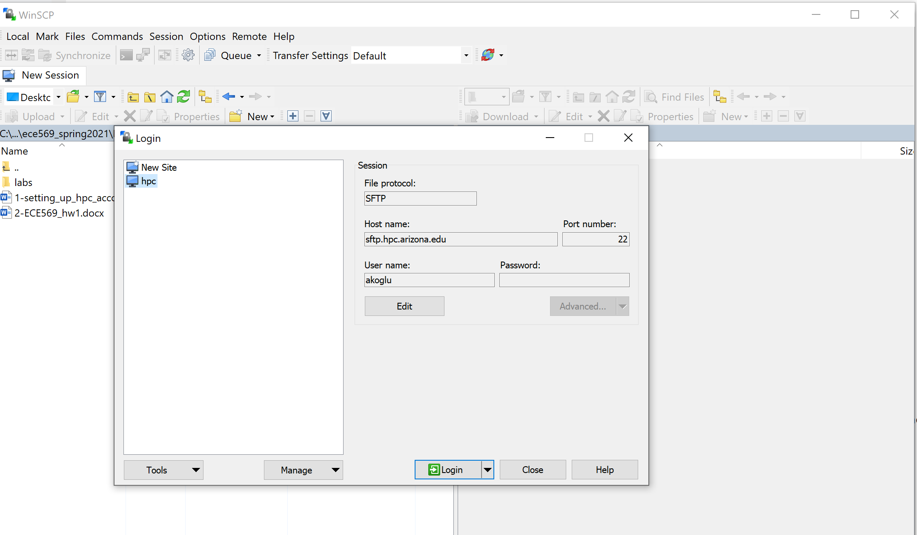

**if you are using putty, first login to hpc.arizona.edu**

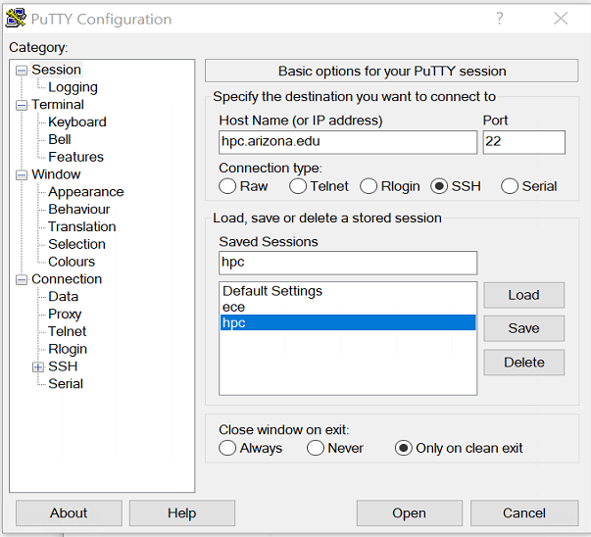

Make sure to enable X11 if you are going to use Xserver

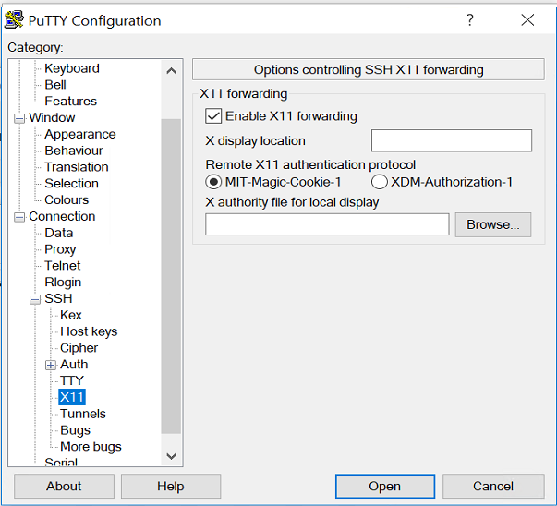

**Accessing Ocelote**

**First read the info at:**

[**https://public.confluence.arizona.edu/display/UAHPC/Ocelote+Quick+Start**](https://public.confluence.arizona.edu/display/UAHPC/Ocelote+Quick+Start)

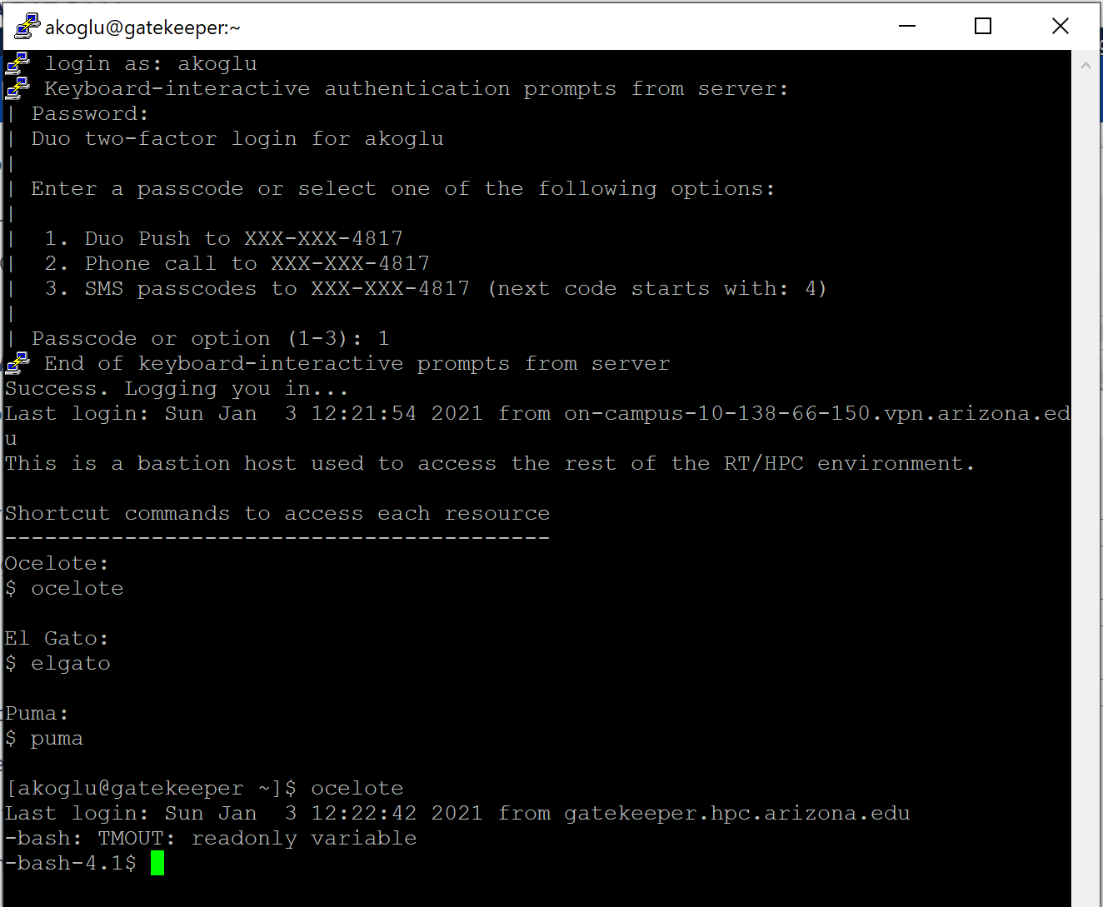

**When you login to hpc,.arizona.edu** you will be at the frontend (“netid@gatekeeper”). You will then connect to Ocelote or Elgato.

**Use the –X option for X11 forwarding above when connecting to ocelote.**

**$ocelote -X**

Information about GPU nodes on UA HPC

<https://public.confluence.arizona.edu/display/UAHPC/GPU+Nodes>

### Alternative ways to access the HPC system (Windows, MAC, Linux) https://public.confluence.arizona.edu/display/UAHPC/System+Access

### MobaXterm

MobaXterm is another available SSH Windows client. To connect to HPC, [download and install MobaXterm](https://mobaxterm.mobatek.net/download.html), open the software, select **Session → SSH** and enter **hpc.arizona.edu** under **Remote host**. Next, select the box next to **Specify username** and enter your UArizona NetID. To connect, click OK at the bottom of the screen:

For ElGato more information is at:

<http://elgato.arizona.edu/getting-started>

Let’s first handle the account creation phase. I will then post the first assignment on running jobs.